IEICE TRANS. FUNDAMENTALS, VOL.Exx ??, NO.xx XXXX 200x
1
PAPER

Reducing the Number of Flushing by Scaling Mixers on PMDs

Masataka HIRAI^{†a)}, Debraj KUNDU^{††b)}, Nonmembers, Shigeru YAMASHITA^{†c)}, Senior Member, Sudip ROY^{†††d)}, Nonmember,
and Hiroyuki TOMIYAMA^{††††e)}, Senior Member

SUMMARY This paper proposes an e cient method for re- ducing the number of ushing operations on Programmable Mi- cro uidic Device (PMD), which consists of an array of valves and cells. Due to its programmability and grid channel-based archi- tecture, an intensive amount of research work has been done on PMD in recent years. During the synthesis of any bioassay (e.g., a mixing tree) on PMD, we may need ushing operations to wash away unnecessary intermediate droplets left in some cells. It is essential to reduce the number of necessary ushing operations as it increases the synthesis time and also the usage of bu er so- lutions. Hence, our proposed method minimizes the ushing by scaling the size of the mixers and transforming the given mixing tree. Our experimental results con rm that after the proposed transformation, we can reduce the number of ushing operations by an average of 81.34%.
key words: Programmable Micro uidic Device (PMD), Flush- ing, Scaling

- Introduction
In recent years, micro uidic biochips have been gaining attention as new experimental devices replacing con- ventional laboratory-scale devices in the eld of bio- chemistry [1] [2] [3]. One type of biochip, called Pro- grammable Micro uidic Device (PMD) [4], has gar- nered particular interest [5] [6] [7]. A PMD consists of a network of ow and control layers, forming an ar- ray of valves and cells. By controlling the opening and closing of valves, PMD creates circular ow paths called mixers to mix multiple droplets [8] [9].
A PMD can generate a mixed solution of multi- ple reagents in the desired ratios by performing a se- quence of mixing operations. This process is called reagent synthesis [4] [10]. During reagent synthesis on a

†The author is with the Graduate School of Information Science and Engineering, Ritsumeikan University, Shiga, 525-8577 Japan.
††The author is with the Technical University of Munich, Muhich, 80333 Germany.
†††The author is with the Indian Institute of Technology Roorkee, Uttarakhand, 247667 India.
††††The author is with the Indian Institute of Technology Roorkee, Uttarakhand, 247667 India.
- E-mail: miku@ngc.is.ritsumei.ac.jp
- E-mail: debraj.kundu@tum.de
- E-mail: ger@cs.ritsumei.ac.jp
- E-mail: sudip.roy@cs.iitr.ac.in
- E-mail: ht@fc.ritsumei.ac.jp DOI: 10.1587/transfun.E0.A.1
PMD, there are cases where intermediate droplets gen- erated by some mixers may be left in cells that should not be used by other subsequent mixers, hindering fur- ther mixing. This state is referred to as mixer over- lap. Mixer overlap should be solved by performing an operation called ushing, where the remaining inter- mediate droplets are washed away with a liquid called bu er solution [11]. The amount of bu er solution used in reagent synthesis increases proportionally with the number of ushing operations, leading to an increase in experimental costs. Moreover, the scheduling time also increases proportionally with ushing operations. Therefore, reducing the number of ushing operations in reagent synthesis is necessary to mitigate the increase in experimental costs.
Various methods of reagent synthesis on PMDs
have been studied [12]. One method for generating droplet mixing sequences in reagent synthesis on PMDs is No Transport Mixing (NTM) [13]. Additionally, a method using priority assignment has been proposed to reduce the number of ushing operations in reagent synthesis [14]. To improve such existing works, this paper proposes a new idea, scaling of mixers, espe- cially for reducing the number of ushing operations in reagent synthesis on PMDs.
Contributions of This Paper.
  Given a mixing tree, we rst focus on the possible mixer overlaps where ushing operations are nec- essary. Then, we utilize a unique idea to transform the mixing tree by scaling some mixing nodes that help to reduce ushing operations.
  We also propose a heuristic for scheduling and placing mixers of the transformed mixing tree.
  Experimental comparisons con rm that our new idea, scaling can indeed reduce the number of nec- essary ushing operations by 81.34% when we per- form droplet mixing procedures for mixing trees of height 5.
This paper is organized as follows. Section 2 ex- plains the basic knowledge of reagent synthesis using PMDs. Section 3 explains our proposed method to re- duce the number of ushing operations in reagent syn- thesis using our new idea: scaling . After that Sec- tion 4 presents the experimental results and discussions.

Copyright   200x The Institute of Electronics, Information and Communication Engineers

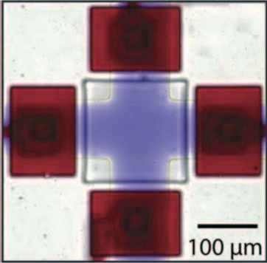
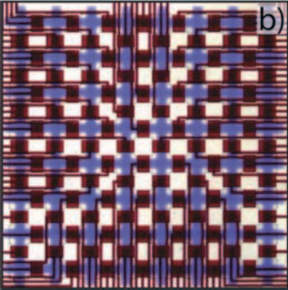
Finally, Section 5 concludes the paper with future work.
- Preliminary

In this section, we explain the preliminaries of a Pro- grammable Micro uidic Device (PMD) and the synthe- sis of any mixing tree on it.

  - Architecture of PMDs

A microscopic image of a PMD is shown in Figure 1, where a ow-channel section (blue) called cells is sur- rounded by four valves (red). The valves are used for manipulating and controlling uid operations and movements within PMD. As evident from Figure 1, PMD has a structure where cells surrounded by valves are arranged in a grid pattern, which increases the pro- grammability of uidic operations on PMD. Figure 2 illustrates the process of mixing droplets of two types of reagents using a PMD [13]. Figures 2 (a-b) demon- strate the injection of two types of reagents into the PMD from input ports by applying pressure. Figure 2
(c) depicts a ow path called a mixer, which consists of cells connected in a circular manner. Mixing of droplets is achieved by controlling the opening and closing of valves in the mixer, which generates a peristaltic mo- tion. After the mixing of droplets, the concentration of droplets on the mixer becomes uniform, as shown in Figure 2 (d). The mixer in Figure 2 (c) uses a 2 × 2 cell con guration of the PMD for droplet mixing. Such a mixer using a 2 × 2 cell con guration is referred to as a 2 × 2 mixer, and its size is referred to as 4 in this work. Using the same approach, we can also con gure larger mixers on PMD.
A mixer is modeled as a collection of continu- ous cells arranged to form a closed loop such that a Hamiltonian cycle exists within the structure. This cyclic path is crucial, as uids are circulated and mixed through peristaltic actuation of valves. Therefore, con-
gurations such as 2 2 or 4 2 cells, as well as rect- angular shapes with notches (provided they contain an even number of cells), are considered valid mixer de- signs. In this work, we focus on mixers with volumes of 4 and 6. However, after a scaling operation, the vol- ume may double, resulting in mixers of volume 8 and
12. To initiate any operation on such mixers, we need to load desired reagents into each cell of a mixer. A loading must start at the in-port, end at the out-port, pass through the required cells to be lled, and avoid intersecting any lled region on a PMD.

  - Reagent Synthesis

Reagent synthesis is the process of generating a desired ratio of certain reagents, which is achieved through a sequence of reagent mixing of PMD. Figure 3 illustrates the input and output data of reagent synthesis using a

Fig. 1: Microscopic image of a PMD.

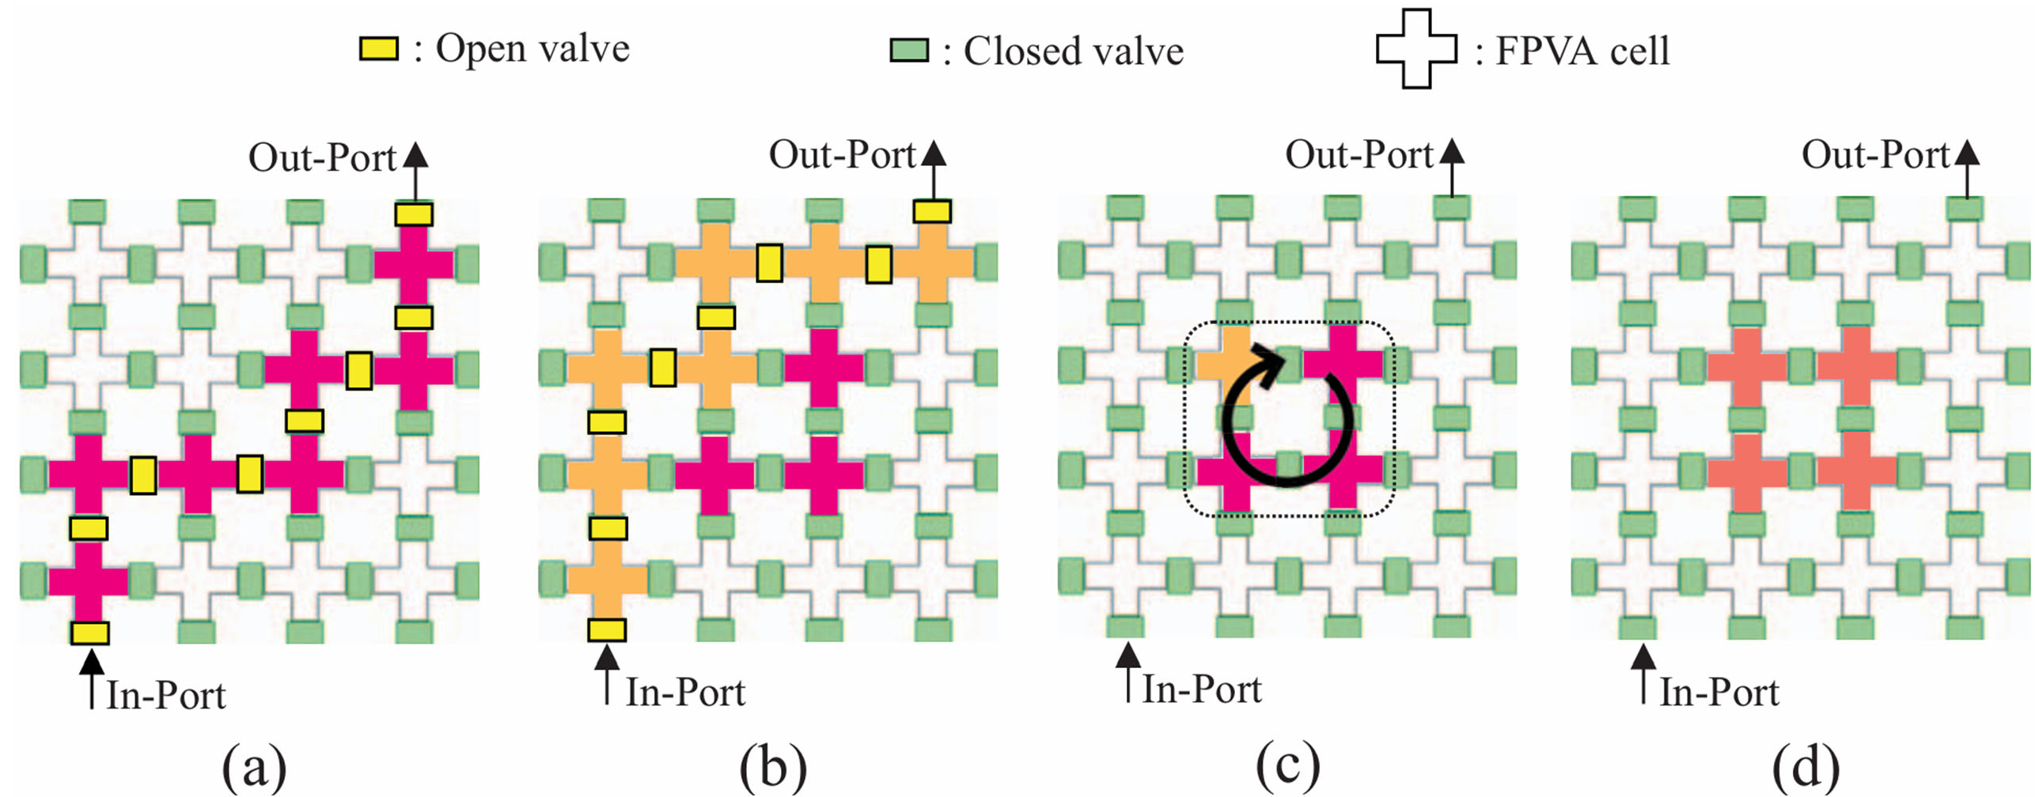
Fig. 2: Process of mixing two types of reagents poured onto a PMD, from reference [13].
.

method based on priority placement [14].
In Figure 3 (a), a tree-structured data called a mix- ing tree is shown, which represents reagent synthesis that mixes four types of reagents, R1, R2, R3, and R4, in the ratio 24:18:12:10. Nodes located on the leaves of the mixing tree represent reagent droplets. Nodes other than reagent nodes represent mixing nodes, de- noting droplet mixing using mixers. Mixing node Mi represents the mixing of droplets in the i^{th} mixer.
Figures 3 (b) to (f) depict the actual droplet mix- ing steps on a PMD corresponding to the logical mix- ing nodes presented in Figure 3 (a). In Figure 3 (b), droplets are mixed at M2 and M3. In order to place M4, a ushing operation to wash out a cell of M3 is shown in Figure 3 (c). Then in the next step M4 is placed as shown in Figure 3 (d). Then in Figure 3 (e) the placement of M1 is shown and nally in Figure 3
(f) M0 is placed. The method based on priority place- ment [14] takes the mixing tree shown in Figure 3 (a) as input and generates droplet mixing steps like those in Figures 3 (b) to (f) by exploring the arrangement of reagents and mixers based on the mixing tree.

  - Flushing

During reagent synthesis on a PMD, there are cases where PMD cells used for mixing between multiple mix- ers may overlap. For instance, in Figure 3 (b-c), we ob- serve that M4 has a single-cell overlap with M3. In such a case, the mixing of M4 cannot be initiated unless the intermediate droplets generated by the previous mixer M3 are removed from the overlapped cell(s). To ensure a proper uid sharing between child nodes and their parent node we need to overlap their placements.
However, some of those placement forces us to wash out certain cells to ensure a proper sharing. This

state is referred to as mixer overlap . In order to get rid o any mixer overlap , we need to wash out the droplets in the concerned cells. This operation is re- ferred to as ushing . Flushing is similar to a loading operation, except that a bu er reagent is used to clear the desired cells within the overlapped region. As with loading, ushing must ensure that the loading path starts at the in-port and ends at the out-port with- out intersecting any lled regions of the PMD, except for the speci c overlapped region which needs to be
ushed. In the mixing tree shown in Figure 3 (a), the child nodes M3 and M4 shares 3 unit and 1 unit vol- ume, respectively to the parent node M1. Once M3 is placed as shown in Figure 3(b), our next task is to place M4, such that when M1 will be placed it should overlap exactly with 3 and 1 cells of M3 and M4, respectively. However, to achieve that we need to ush a cell from M3 (Figure 3(c)) and then we have to place M4 (Fig- ure 3(d)). Finally, as shown in Figure 3(e), we need to place M1 with proper overlapping with its child nodes.





This example implies that if the sharing volumes to a parent node from two child nodes is 3:1 or 5:1; there should always be mixer overlap between those child nodes. As shown in Figure 3(c), to resolve this overlap issue ushing is performed by a bu er solu- tion, that wash away the intermediate droplet residing in the cell marked as shaded region. As ushing opera- tion increases the completion time for the synthesis of a mixing graph, our proposed method aims to reduce the number of necessary ush operations. Our observation is that it is possible to predict the mixer overlap to some extent based on the size of the child mixers and the shared volumes to their parent mixer, which will be discussed in the next section.

(c)
0
(f)
1
(b)
(e)
3
2

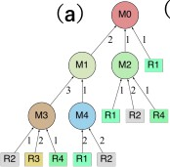
(a)

4
(d)
Fig. 3: A mixing graph, and the di erent stages of the reagent synthesis via placement of its mixing nodes.

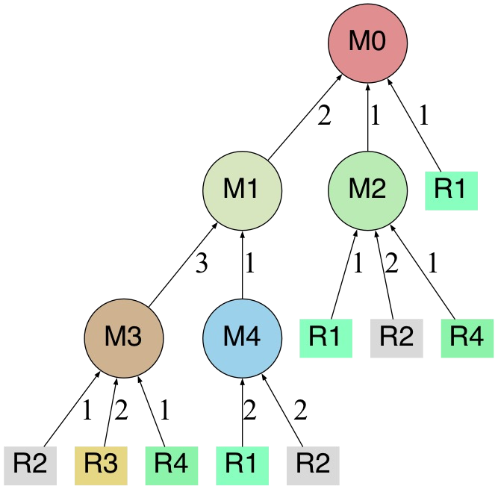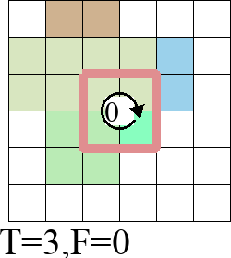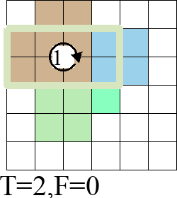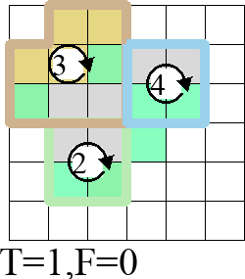
（a）
（b）
（c）
（d）
Fig. 4: (a) Input for the proposed method: mixing trees, (b), (c) and (d) Output: mixing procedure of droplets on a PMD.

- Reducing the Number of Flush Operations by Scaling Mixers
  - Outline of the proposed method

Here, we describe the outline of the proposed method. The input to the proposed method is a mixing tree, as shown in Figure 4 (a) and the output is the scheduled mixer placement information, as shown in Figure 4 (b- d). In Figure 4 (b-d), the value T means the time step when the mixing occurs, and the value F means the number of ush operations performed before T. The proposed method aims to perform reagent synthesis with fewer ush operations compared to the existing method using placement priority mentioned in the pre- vious section [14].
Our proposed method can be broadly divided into two processes: (i) transformation of the input mixing tree using scaling, and (ii) heuristically determining the scheduling and the placement of mixers (Mi) in the mix- ing tree.

  - Transformation Algorithm for Input Mixing Trees using Scaling

In this section, we describe the transformation process of an input mixing tree by using our new idea: scaling .

    - Overview of Scaling

Scaling of a mixer is an operation that multiplies all the input volumes of a mixer Mi by the same integer factor, such as double, triple, etc. For instance, after scaling the input volumes of M5 , which is 3:1 in the original mixing tree shown in Fig.5 (a), the input vol- umes are doubled to 6:2 in the modi ed mixing tree Fig.5 (c). Additionally, due to the Scaling , the mixer size of M5 has changed from 4 to 8. By using Figure 5, we explain in a detail how we transform a mixer by us- ing scaling. First, between Figures 5 (a) and (b), the input volumes to M5, which is the target of the scaling, is doubled. As a result, in some cases, contradictions may arise within the mixing tree, as shown in Figure 5
(b). The contradiction in the mixing tree in Figure 5
(b) arises from the mixer node M9 whose size is 4 but it

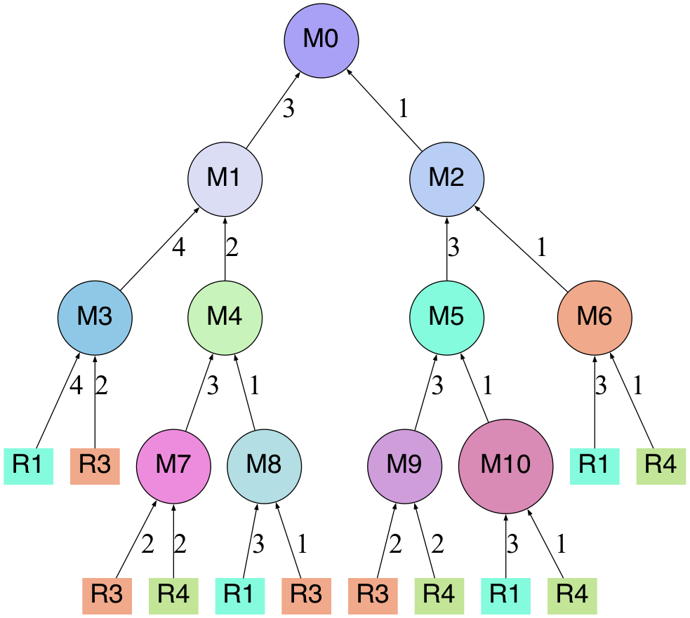
6 2
6 2
4 4
(a) (b) (c)
Fig. 5: Details of the transformation of input mixing trees using scaling.
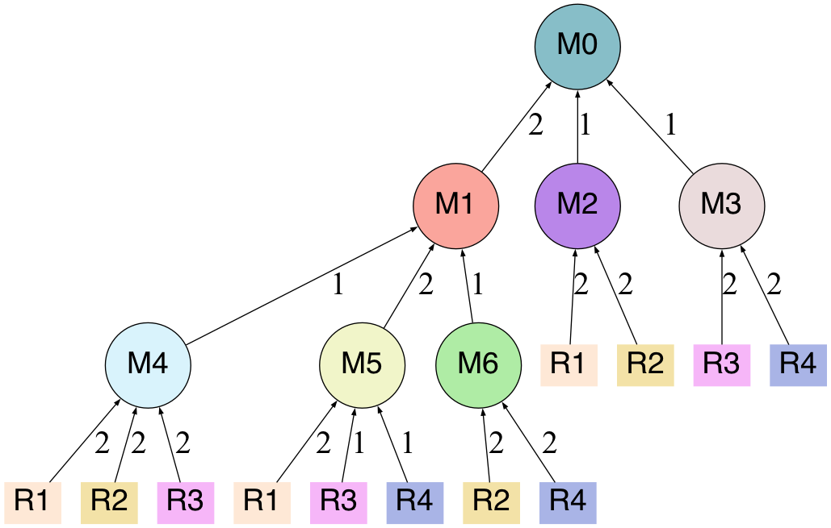
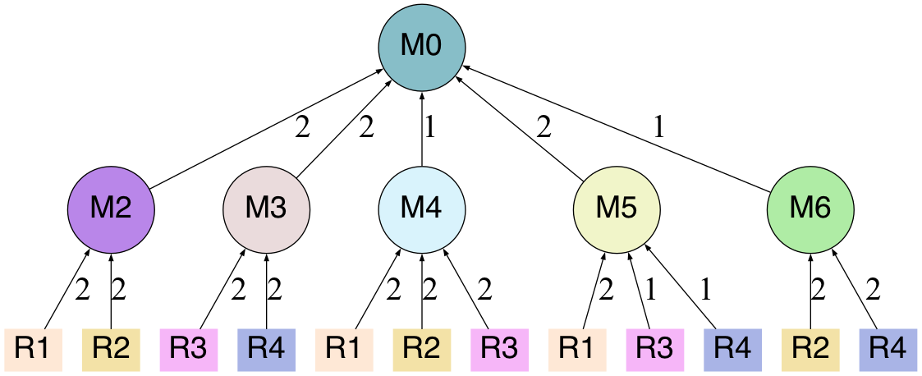
4 2 2
(a)
(b)
Fig. 6: Merge of mixer nodes during scaling.

should provide 6 intermediate droplets to M5. A mixer cannot provide more intermediate droplets than its own size. In order for the mixer of M9 to provide 6 interme- diate droplets to the parent node, M5, the mixer size of M9 needs to be increased to at least 6. Therefore, between Figures 5 (b) and (c), the input volume to M9 is also doubled by scaling, increasing the mixer size of M9 to 8. The scaling of the input volumes to M9 re- solves the contradictions within the mixing tree. After Scaling, it may be possible to merge some mixer nodes. An example of a mixing tree where mixer node merging is performed after Scaling is shown in Figure 6. In Fig- ure 6, Scaling is performed on the input volumes to M0. Due to the scaling, the input volumes to M0, which is 2:1:1 in the mixing tree as shown in Figure 6 (a), be- comes 4:2:2 in the mixing tree as shown in Figure 6
(b). In the mixing tree as shown in Figure 6 (b), M1 is a size-4 mixer, and it provides all 4 droplets mixed in the mixer to the parent node M0's mixer. Therefore, we can just transfer all the 4 input droplets of M1 di- rectly to M0 without mixing them in M1. Since mixing of droplets in M1 is unnecessary, M1 can be merged
into M0. This simpli cation is called merging of mixer nodes, which transforms the mixing tree from Figure 6
(b) to Figure 6 (c).
The architectural constraints of PMD with a sin- gle inlet and outlet port, incurs reagent wastage during its loading operation. To load m cells, n − m cells of reagent wastage will be incurred in each loading cy- cle, where n is the length of the loading path. Since the ow cannot be stopped precisely at the point when the loading path is lled, it is necessary to ow much more reagent than required. In conclusion, the reagent wastage highly depends on the number of loading cy- cles, and not on the number of cells loaded. Hence, to reduce reagent wastage, we need to reduce the num- ber of loading cycles required for the entire operation. The theory behind Scaling is to reduce the number of
ushing and eventually helps in reducing overall load- ing cycles. The additional reagent usage introduced by Scaling, relative to multiple loading cycles, is negligi- ble. Hence, the Scaling does not signi cantly a ect the reagent requirement for the entire process. On con- trary, merging of mixing nodes due to Scaling reduces

the number of loading counts for reagents, which in turn helps in reducing reagent wastage.

    - Overview of Mixer Overlap

It is possible to predict the occurrence of mixer overlap to a certain extent based on information such as the input volumes of a mixer. Our idea is to consider the relationship between input volumes and mixer overlap as follows. We consider the following three groups of mixers based on input volumes to predict the likelihood of mixer overlap during reagent synthesis.
Group A Mixers that provide 3 or more odd- numbered droplets to their parent mixer node.
Group B Mixers that provide 4 or more even- numbered droplets to their parent mixer node.
Group C Mixers that provide less than 3 droplets to their parent mixer node.
A mixer in Group A has higher probability to cause a
mixer overlap , as shown in Figure 3 (a), where M3 provides 3 unit droplets to M1 causing a mixer over- lap . To ensure a no-transport placement, child mixer nodes are positioned to overlap with the placement cells of their parent mixer node such that the number of over- lapped cells matches the number of shared droplets. Therefore, especially when the size of the parent mixer is small, such as 4 or 6, the placement cells of child mixers are more likely to be placed close to each other, which increases the chance of mixer overlap .
As explained in Section 3.2.1, Scaling enlarges the mixer size, which convert the mixers from Group A to Group B, and reduces the chance of mixer overlap . However, due to the size increment of the parent mixer by Scaling, the demand from it's child nodes also in- creases. As a result we also need to increase the size of the respective child nodes in equal proportion. Conse- quently, as the size of the parent mixer increases, the options for arranging child mixers also increase, mak- ing it easier to select an arrangement that avoids mixer overlap . After the Scaling we will be left with mixers belonging to either Group B or Group C. The di er- ence between these two groups lies in the number of droplets provided, expecting that Group C has a very low probability of causing overlaps.
In Figure 7 (a), applying Scaling transforms the mixing tree into the one as shown in Figure 7 (b). When we generate the mixing procedure on a 10x10 cell PMD by the algorithm mentioned in Section 3.3, the mixing tree in Figure 7 (a) requires four ush op- erations for the reagent synthesis, while with the pro- posed approach we need only one ush operation for the mixing tree, as shown in Figure 7. Flushing is de- pendent on (i) placement of the mixers, (ii) size of the mixers, and (iii) size of PMD. The following example shows that even though we have enough space with a 10x10 PMD, the mixing graph in Fig. 8(a), will always
require 4 ushing. Hence, we aim to determine an ef-
cient placement that reduces the number of ushing requirement for mixer overlap .

  - Algorithm for Generating Droplet Mixing Proce- dure Using Large Mixers on a PMD

Our proposed method to generate droplet mixing pro- cedures on a PMD can be broadly divided into two steps. The rst step is to reorder the sequence of mixer placement for a reagent synthesis based on the esti- mated number of cells used by each sub-tree in a given mixing tree. This process involves rearranging the de- cision sequence of mixer placement based on a metric called estimated cell use number (ECN), which will be de ned later. The second step is determining how to place mixers based on the ECN.
    - Algorithm for Reordering Decision Sequence of Mixer Placement Using Estimated Cell Use Numbers (ECN)

In the algorithm for reordering the decision sequence of mixer placement using the ECNs, we calculate an estimated cell use number (ECN) for each mixing node in the input mixing tree. ECN for a mixing node Mn (where n is the mixing node number) is calculated using Equation 1. The ECN is computed as the sum of the reagent volumes (Reagent Vol.) for Mn and the ECNs of its child nodes.
ECN(M n) = ReagentVol(M n)+
Σ ECN(M n's child nodes). (1)
Equation (1) for the Estimated Cell Use Number calcu- lates the maximum sum of cell usage for mixing droplets across all mixing nodes in the subtree rooted at the tar- get mixing node.
After calculating ECNs, the child nodes of each mixing node are reordered according to their ECNs. For example, in Table 1, the ECN(M2) > ECN(M1). Therefore, the placement decision for M0's child nodes is made, which states M2 must be placed before M1.
Our proposed approach utilizes ECNs as an ap- proximate measure of the number of cells required by the mixing nodes in the sub-tree until all droplet mix- ing is completed. Mixing nodes having higher ECNs are more likely to overlap with other mixers, as they require more cells until all the mixing operations in the

Table 1: Estimated cell use numbers assigned to each mixing node in the mixing tree of Figure 7 (b).
 | M1 | M2 | M3 | M4 | M5 | M6 | M9 | M10 | M11
ECNs | 20 | 22 | 12 | 8 | 12 | 10 | 6 | 6 | 8

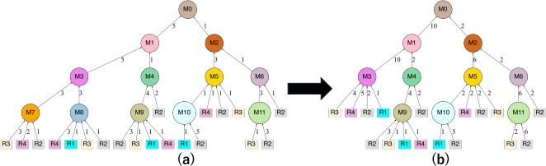
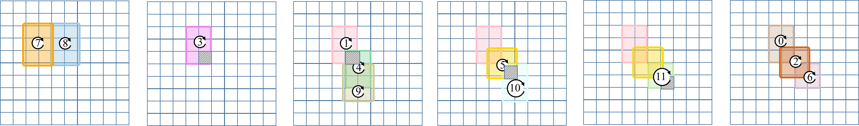
(c)

Fig. 7: Illustration of a mixing graph (a) before and (b) after Scaling. (c) Sequence of placement for the mixing nodes in the graph shown in Fig. 7(a) on a 10 × 10 PMD, which requires 4 ushing due to mixer overlap .

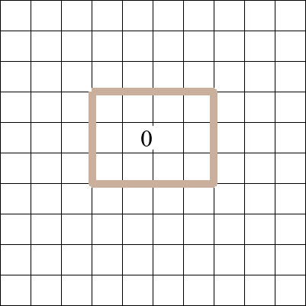
2
2
(3,3)
1
(0,0) (1,0) (2,0) (3,0)
(0,1) (1,1) (2,1) (3,1) (4,1)

(1,2) (2,2) (3,2) (4,2)
(7,6) (8,6)

(5,7) (6,7) (7,7)

(5,8)
(9,8)
(6,9) (7,9) (8,9) (9,9)
(6,8) (7,8) (8,8)
(9,7)
(8,7)
Z2 = [{(0,0), (1,0), (2,0), (3,0), (0,1), (1,1), (2,1), (3,1)},
{(1,1), (2,1), (3,1), (4,1),(1,2), (2,2), (3,2), (4,2)}, ... ]
1

(a)
(b)
(c)

Fig. 8: (a) Process of determining the mix positions using mixing window. Placement of the child nodes of M0, (b)
without ushing, and (c) with ushing.

sub-tree are completed.
Hence, our approach prioritizes the placement of nodes with higher ECNs and place them earlier when more empty cells are available on the given PMD. This ensures that we have more freedom to select the place- ment con gurations that prevent mixer overlap as much as possible.

    - Mixing Node Placement Algorithm

In this section, we explain the second step of the pro- posed method. As mentioned earlier, we determine the placement of mixers according to the reordered place- ment schedule, based on ECNs. For a given mixing tree and an NxM PMD, let L be the ordered list of the mixers to be placed. Considering these inputs, we then propose an iterative approach for placing the mixers to minimize the number of ushing operations. At each it- eration, we place all the child mixers of a parent mixer. Using the size of each mixer, we determine all possible mix positions using mixing-window for that mixer, and then enumerate all valid placements of the child mixers that maintain proper overlap with their parent. The placement order of the child mixers is determined by
their ECN values, with mixers having larger ECN val- ues placed rst. The proposed placement approach is presented in Algorithm 1.
At each iteration, we choose a parent mixer and then according to its known placement we aim to nd a good placement of its child mixers. In the rst itera- tion, at line 4 of Algorithm 1, we choose to place the root node at the center of the chip. For next iterations, we always get the placement of the parent mixer from a previous step. The satisfying conditions for the place- ment ensuring proper mixing are presented in line 14. Out of all possible placements stored in P , we choose the placement with minimum ushing requirement at line 15 Finally, at line 17 we get the nal placement
con gurations of each mixer stored in P¯.
Figure 8(a) shows the technique to determine all possible mix positions for a given size mixer. We rst choose a widow of the same size as the mixer and then scan that window across a PMD and choose the corre- sponding cells. Figures 8 (b) and (c) show two di erent placements of mixers of M1 and M2, which are child nodes of M0. We need to place the child nodes M1 and M2 in a way that shares 10 and 2 droplets, respectively, with the parent node M0. The placement method in

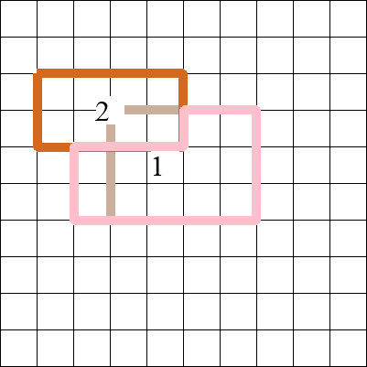
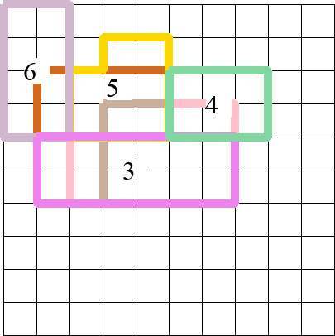
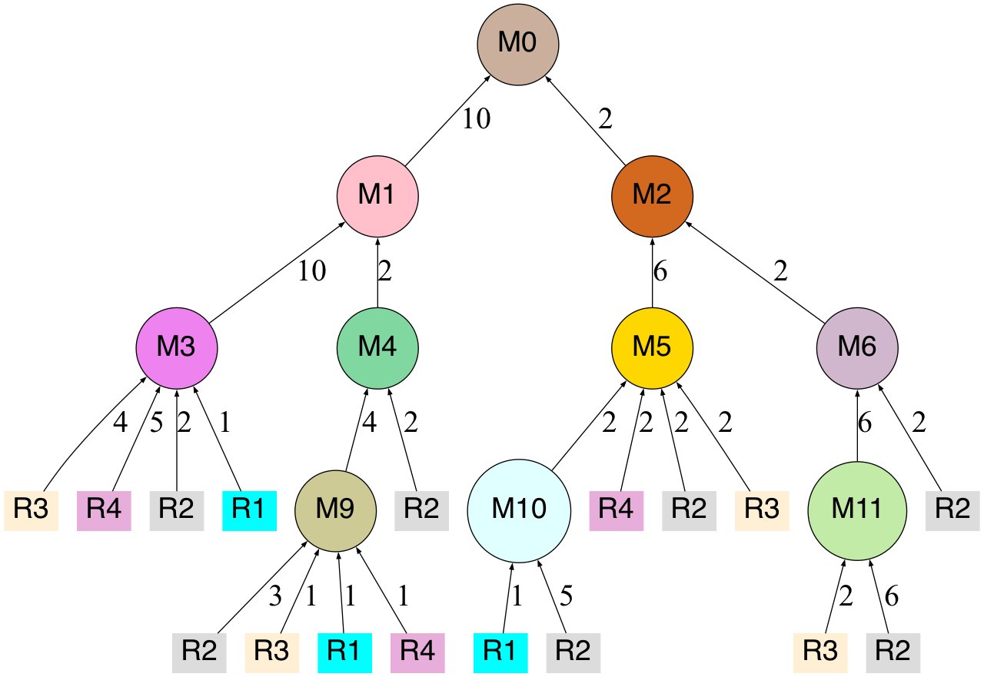
(0,0)
(c)
(a)
(d)
(b)

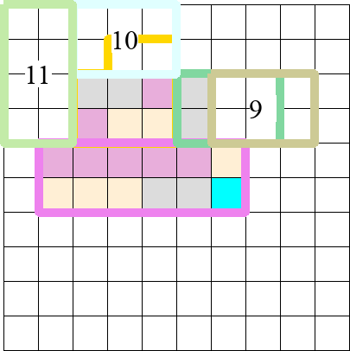
(e)

Fig. 9: The process of placing mixers on a 10x10 cell PMD.

Figure 8 (b) allows the mixer cells of M1 and M2 not to overlap with each other, enabling the placement of M1 and M2 mixers in the same time step. However, according to the placement shown in Figure 8 (c), the mixer cells of M1 and M2 overlap with each other. As mentioned in Section 2.3, such "mixer overlap" needs
ush operations. However, the provided droplets to the parent node M0 should not be washed away be-

Algorithm 1: Mixer Placement

1 Input: (i) Mixing tree (T ) consisting of Mi and Rj, (ii)
placement sequence (L) of Mi based on ECN, and a PMD of size N × M
Output: Placements of the mixers Mi on PMD
2 begin
3 while L is NOT Empty do
4 X ← L[0];/* X is the current parent node */
5 X¯ ← add the placement cells of L[0];/* for root node M0, place at the center of N × M */
6 Y = {};
7 Y ← child mixining nodes of X;
8 if Y ̸= {} then
9 for i ← 1 to |Y | do
10 Zi ← add all possible mix positions
w.r.t the size of Yi;
11 C ← Z₁ × Z₂ · · · × Z_{|Y} |;/* cross product of
∀iZi */
12 P = {{}₁, {}₂, · · · , {}_{|C|}};
13 for i ← 1 to |C| do
14 for j ← 1 to |Ci| do
−−−→
/* Yj, X denotes the edge weight
between the child Yj and parent X */
15 Pi ← Pi ∪ Ci,j , such that
V
cause they will be required for mixing at M0. Thus, in the placement method of Figure 8 (c), if the mixers are placed in the order of M2 followed by M1, the pro- vided droplets to M0 left by M2 at cells (3,3) and (4,3) need to be ushed away to allow mixing by M1. Conse- quently, it is impossible to perform mixing by placing the mixers in the order of M2 followed by M1 in the placement method of Figure 8 (c).
For determining the mixer placement, the pro- posed method rst generates all the possible place- ments, as shown in Figure 8(a). Then, it evaluates the number of ush operations needed for each placement. When we evaluates the number of ush operations, as explained in Section 3.3.1, the proposed method rear- ranges the order of mixer placement based on the ECN values. However, as mentioned in the example shown in Figure 8 (c), there may be an inappropriate order of mixers; we simply exclude such orders. We select the best placement and the order of child mixers which minimizes the number of ush operations.
Figure 9 illustrates the placement sequence on 10×
10 PMD. The top-left cell of the PMD in Figure 9 is denoted as (x, y) = (0, 0). Figure 9 (a) represents the same mixing tree as Figure 7 (b). Initially, the root mixing node M0 is placed at the centre of the PMD, as shown in Figure 9 (b). Next, as illustrated in Figure 9 (c), mixers of child nodes M1 and M2 of M0 are placed on the PMD, overlapping with the placement cells of the M0 mixer. This process continues, as shown in

|X ∩ C
−−−→
i,j | ≥ Yj, X X ∪ C
i,j ≤
Figure 9 (d) and (e), where mixers of child nodes are

N × M ;
16 P¯ ← add the placement from P requring smallest ush operation;
17 Remove L[0] from L;
18 return Placement information stored in P¯;
placed overlapping their parent mixer nodes.
During the mixer placement with enlarged mixers, we may run out of empty cells on PMD, leading to an impossible placement. In such a case, the opera- tions proceed in the following order: loading of reagent

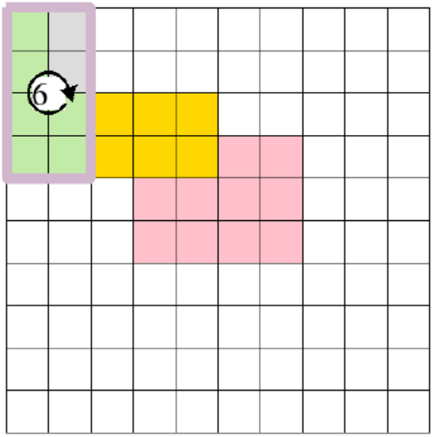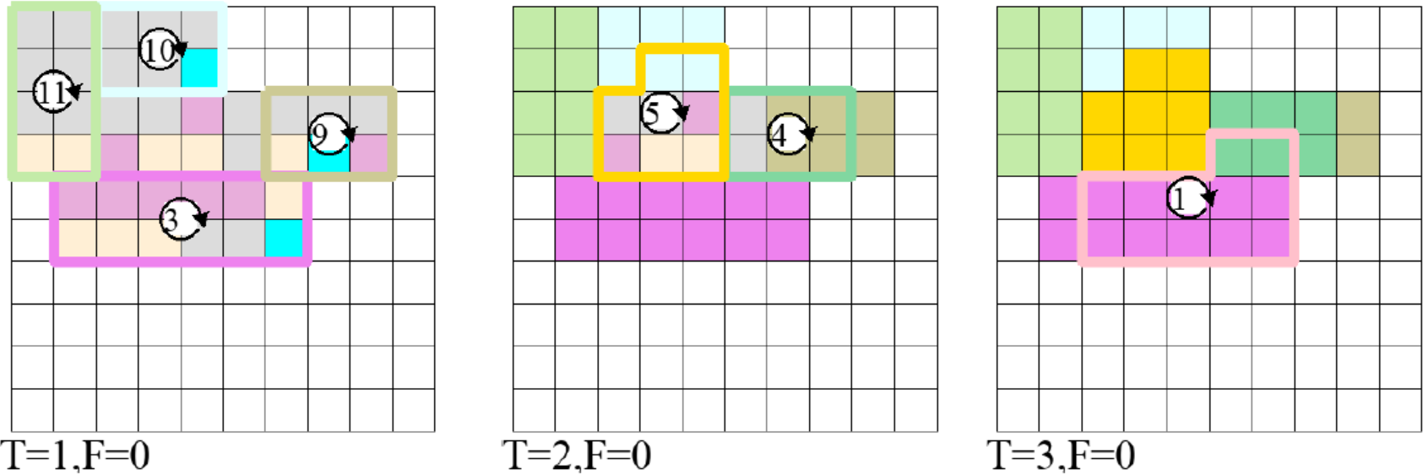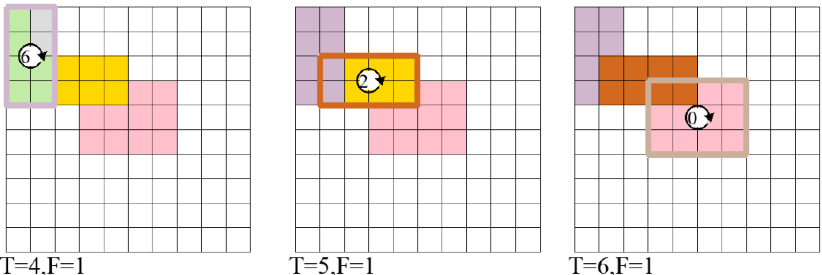
Flushing
In-port
Out-port

: closed valve
: buffer flow
Fig. 10: Mixing procedure for reagent synthesis corresponding to the mixing tree in Figure 9(a).

droplets, mixing of droplets in the mixers, and ush- ing. Flushing creates space on a PMD, allowing for the continuation of mixer placement. The sequence of oper- ations repeats, with mixer placement, reagent loading, mixing of droplets in mixers, ushing, and again mixer placement. Eventually, when the mixing of M0 is com- pleted, the droplet mixing procedure as shown in Fig- ure. 10 is generated. In Figure. 10, T represents the time step at which mixer mixing occurs, and F rep- resents the number of ush operations performed until that time step. For the droplet mixing procedure cor- responding to the mixing tree as shown in Figure. 9(a), it is evident that one ushing is required.
After placing the mixers starting from the root node, the reagent loading and mixing operations are performed in reverse order. Accordingly, we rst load reagents into the mixing nodes that do not have any child nodes As depicted in Figure. 9, droplet mixing takes place starting from the mixers of the leaf mix- ing nodes, as shown in Figure. 10. In the rst step reagents are loaded and mixed for M3, M9, M10 and M11 as shown in Figure. 10 at T=1. Then we repeat the same procedure for the successive parent mixing nodes. At T = 4, before mixing M6, we need to ush 2 cells from the previously placed M11, and load there with R2. So at T=4, we need a ushing operation for which F increases to 1.

- Experimental Results

To evaluate the e ect of scaling in the proposed method, we rst generate mixing trees of heights 3, 4, and 5 randomly, with 300 mixing trees generated for each height as our benchmark input mixing trees, and then we generate the mixing procedures of each of the
input mixing trees by our method with/without scaling by assuming a 10x10 PMD. It is di cult for us to com- pare our method exactly with the existing method [14], but we could consider that the existing method would be almost similar to our method without scaling.
Table 2 shows the comparison between the two methods with and without scaling. In Table 2, the sec- ond column from the left shows the average number of nodes in the input mixing trees. (Note that the height includes the leaf reagents, so a mixing trees of heights 3 has two levels of mixing nodes.) The third and fourth columns show the average number of overlaps of mixers by the method without and with scaling, and the fth column shows the average reduction rate by scaling. The sixth and seventh columns show the average num- ber of necessary ush operations by the method with- out and with scaling, and the eighth column shows the

Estimated Flushing Time vs. Tree Height
W.O. Scaling
W. Scaling
35
Average Time for Flushing

30

25

20

15

10

5

0
3 4 5
Height of Mixing Tree

Fig. 11: Comparison of the estimation of average ush- ing time before and after Scaling operation.

Table 2: Experimental results.
Height of  Mixing Tree | Avg. Number  of Mixers | Avg. Number of Overlaps |  | Avg. Reduction  of Overlaps (%) | Avg. Number of Flushing |  | Avg. Reduction  of Flushing (%)
Height of  Mixing Tree | Avg. Number  of Mixers | W.O. Scaling | W. Scaling | Avg. Reduction  of Overlaps (%) | W.O. Scaling | W. Scaling | Avg. Reduction  of Flushing (%)
3 | 3.097 | 0.277 | 0.003 | 98.92 | 0.3 | 0.003 | 99.00
4 | 6.663 | 1.063 | 0.27 | 74.60 | 1.095 | 0.238 | 78.26
5 | 11.449 | 2.449 | 0.493 | 79.87 | 2.406 | 0.449 | 81.34

average reduction rate by scaling. The total processing time is in uenced by three main factors: (i) mixing,
(ii) ushing, and (iii) reagent loading. However, mix- ing time is highly dependent on uid properties, and loading time varies with the chosen loading algorithm. Therefore, we exclude these two components from our calculation of overall processing time. Although the scaling operation may increase the size of some mixers, potentially a ecting mixing time, it also reduces the total number of mixing operations. Hence, the result- ing variation in mixing time is considered negligible. In this work, we focus on evaluating the e ectiveness of our approach in minimizing ushing time. In practice, during a ushing we need to con gure a loading path for the bu er, that passes through the desired cells and cleaned them for the future reagents to be placed.
According to Fidalgo et al. [13], to load a uid in a cell, a PMD takes 7.6 sec. to con gure all the valves and then to ush out the contents of that cell. As the number of cells needed to be washed can be one or more, in most cases we need to con gure at least two separate bu er paths to ush out the contents. Hence, to get an estimation of the average time required for ushing, we multiply the average number of ushing with (2 × 7.6). We compute and report an estimation of average ush- ing time without and with Scaling in Figure 11, which demonstrates that the proposed Scaling operation sig- ni cantly reduces the total time required for ushing. As presented in Figure 11, for height 5, the time re- quired for ushing reduces from 36.57 sec. to 6.82 sec. after the Scaling operation. From this, we conclude that the proposed Scaling approach reduces the overall operation time required to synthesize a mixing graph.
Note that it is possible to resolve two or more over- laps by a single ush operation. Also, we may need a
ush operation when there is no space left on a PMD. Thus, the number of overlaps does not necessarily re- late to the number of ush operations. However, from the experimental results, we can observe that a smaller number of mixer overlap would need fewer ushing. Thus, our hypothesis underlying the proposed method, which states that reducing the number of overlaps is crucial in reducing the number of ush operations has been demonstrated to be somewhat correct. Mixing trees with larger heights are more likely to contain many mixing nodes that we can scale. Therefore, it is expected that taller mixing trees will be more af- fected by scaling transformations, leading to reduction in ushing operation as shown in experimental results.

- Conclusion
A programmable micro uidic device is an advanced mi- cro uidic biochip, which e ciently executes various u- idic operations and bioassays. In spite of the advan- tages of PMD, ushing is one of the most costly opera- tions where we need to wash-out certain PMD cells. In this work, we propose a method to reduce the number of ushing cycles required to automate bioassays on PMDs. We propose a heuristic choice Scaling , that transforms the given mixing tree and a heuristic ap- proach to determine the placement of mixers. Exper- imental results con rm that it reduces the number of
ushing operations by 81.34% while executing mixing trees of height 5. However, in future, we may need to develop an exact algorithm that optimizes mixer place- ment and minimizes the number of ushing operations.
References

- H. Stone, A. Stroock, and A. Ajdari, Engineering ows in small devices: Micro uidics toward a lab-on-a-chip, An- nual Review of Fluid Mechanics, vol.36, no.1, pp.381 411, 2004.
- J.P. Urbanski, W. Thies, C. Rhodes, S. Amarasinghe, and
T. Thorsen, Digital micro uidics using soft lithography, Lab on a Chip, vol.6, no.1, pp.96 104, 2006.
- V. Gubala, L.F. Harris, A.J. Ricco, M.X. Tan, and D.E. Williams, Point of care diagnostics: status and future, Analytical chemistry, vol.84, no.2, pp.487 515, 2012.
- L.M. Fidalgo and S.J. Maerkl, A software-programmable micro uidic device for automated biology, Lab Chip, vol.11, no.9, pp.1612 1619, 2011.
- A. Grimmer, B. Klepic, T.Y. Ho, and R. Wille, Sound valve-control for programmable micro uidic devices, 2018 23rd Asia and South Paci c Design Automation Conference (ASP-DAC), pp.40 45, 2018.
- S. Maruyama, D. Kundu, S. Yamashita, and S. Roy, Op- timization of uid loading on programmable micro uidic devices for bio-protocol execution, 2020 25th Asia and South Paci c Design Automation Conference (ASP-DAC), pp.550 555, 2020.
- G. Liu, Y. Zhu, W. Guo, and X. Huang, Fault-tolerance- oriented physical design for fully programmable valve array biochips, 2023 60th ACM/IEEE Design Automation Con- ference (DAC), pp.1 6, 2023.
- T. Fu and Y. Ma, Bubble formation and breakup dynamics in micro uidic devices: A review, Chemical Engineering Science, vol.135, no.2, pp.343 372, 2015.
- C. Liu, B. Li, B.B. Bhattacharya, K. Chakrabarty, T.Y. Ho, and U. Schlichtmann, Testing micro uidic fully pro- grammable valve arrays (fpvas), Design, Automation Test in Europe Conference Exhibition (DATE), 2017, pp.91 96, 2017.

- S. Poddar, G. Fink, W. Haselmayr, and R. Wille, A generic sample preparation approach for di erent micro uidic labs- on-chips, IEEE Transactions on Computer-Aided Design of Integrated Circuits and Systems, vol.41, no.11, pp.4612 4625, 2021.
- Y.H. Lin, T.Y. Ho, B. Li, and U. Schlichtmann, Block-
ushing: A block-based washing algorithm for pro- grammable micro uidic devices, 2019 Design, Automation Test in Europe Conference Exhibition (DATE), pp.1531 1536, 2019.
- S. Bhattacharjee, B.B. Bhattacharya, and K. Chakrabarty, Algorithms for sample preparation with micro uidic lab- on-chip, CRC Press, 2022.
- G. Choudhary, S. Pal, D. Kundu, S. Bhattacharjee, S. Ya- mashita, B. Li, U. Schlichtmann, and S. Roy, Transport- free module binding for sample preparation using micro u- idic fully programmable valve arrays, 2020 Design, Au- tomation Test in Europe Conference Exhibition (DATE), pp.1335 1338, 2020.
- M. Hirai, D. Kundu, S. Yamashita, S. Roy, and
H. Tomiyama, Transport-free placement of mixers for re- alizing bioprotocol on programmable micro uidic devices, 2023 36th International Conference on VLSI Design and 2023 22nd International Conference on Embedded Systems (VLSID), pp.193 198, 2023.

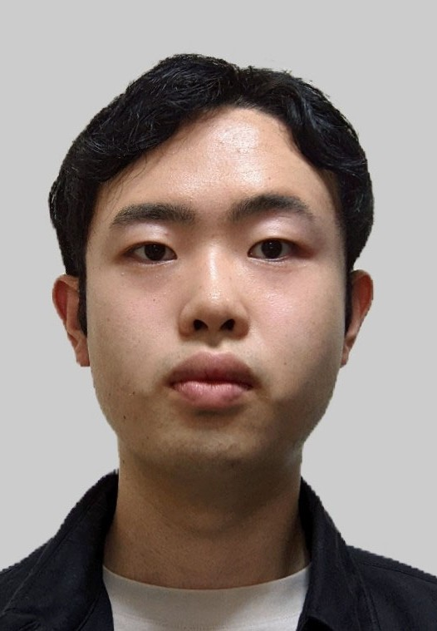
Masataka Hirai received his bache- lor's degree from College of Information Science and Engineering, Ritsumeikan University in 2022. He received his mas- ter's degree from Graduate School of In- formation Science and Engineering, Rit- sumeikan University in 2024. He is cur- rently with LIXIL Corporation.


Debraj Kundu received the bache- lor's degree in computer science and en- gineering from the West Bengal Univer- sity of Technology in 2014 and the mas- ter's degree in computer science and engi- neering from the University of Calcutta in 2016. In 2023, he received Ph.D. degree from the Indian Institute of Technology Roorkee, India. His primary research in- terests include algorithm designing for the automation of bioprotocols on advanced
micro uidic biochips. He was a JSPS postdoctoral fellow at Rit- sumeikan University, Japan and is currently working as a post- doctoral fellow at the Technical University of Munich, Germany.

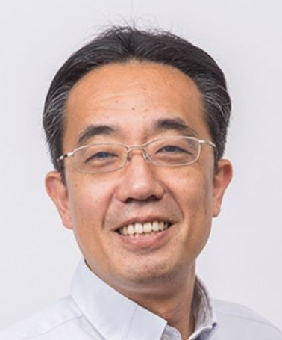
Shigeru Yamashita is a professor at the Department of Computer Science, College of Information Science and Engi- neering, Ritsumeikan University. He re- ceived his B.E., M.E. and Ph.D. degrees in Information Science from Kyoto Uni-
versity, Kyoto, Japan, in 1993, 1995 and 2001, respectively. His research interest s include new types of computation and logic synthesis for them. He received the 2000 IEEE Circuits and Systems Society
Transactions on Computer-Aided Design of Integrated Circuits and Systems Best Paper Award, SASIMI 2010 Best Paper Award, 2010 IPSJ Yamashita SIG Research Award, and 2010 Marubun Academic Achievement Award of the Marubun Research Promo- tion Foundation. He is a senior member of IEEE and a senior member of IPSJ.


Sudip Roy is currently an associate professor in the department of computer science and engineering, (Indian Institute of Technology (IIT) Roorkee, India af- ter joining in July 2014. He received the B.Sc. degree (honors) in physics and the B.Tech. degree in computer science and engineering from the University of Calcutta, India, in 2001 and 2004, re- spectively, and the MS (by research) and Ph.D. degrees in computer science and en-
gineering from the IIT Kharagpur, India, in 2009 and 2014, re- spectively. He has authored one book, one book chapter, two granted U.S. patents and one grated Indian patent including 32 research articles in international peer-reviewed journals and 57 papers in international peer-reviewed conference proceedings. He is a recipient of the Japan Society for the Promotion of Science (JSPS) Invitational Fellowship in the Long-Term category in 2021, the Early-Career Research (ECR) Award from Department of Science and Technology (DST), Govt. of India in 2017, and Microsoft Research India PhD Fellowship Award in 2010. He is a member of IEEE and ACM. His current research interests include computer-aided-design for digital systems, optimization techniques, internet of things (IoTs), and application of machine learning and arti cial intelligence.

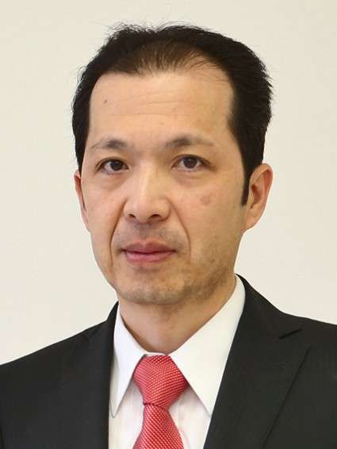
Hiroyuki Tomiyama received his B.E., M.E., and D.E. degrees in Computer Science from Kyushu University in 1994, 1994, and 1999, respectively. He has held positions as a Visiting Researcher at UC Irvine, a Researcher at ISIT/Kyushu, and an Associate Professor at Nagoya Univer- sity. Since 2010, he has been a Full Pro- fessor at the College of Science and Engi- neering, Ritsumeikan University. In 2024, he assumed the role of Senior Executive
Director of the Research Organization of Science and Technology at Ritsumeikan University. He has served on program and or- ganizing committees of several prestigious conferences, including General Chair of MPSoC 2013, Program Chair of RTCSA 2023, and Steering Committee Chair of ATAIT. He has also served as Editor-in-Chief of IPSJ TSLDM, Associate Editor of ACM TO- DAES, IEEE ESL, and Springer DAEM, and Chair of the IEEE CS Kansai Chapter and IEEE CEDA Japan Chapter. His re- search interests include design methodologies for embedded and cyber-physical systems.

